Design Document

**(V1)**

Author:Angel Rusev Date:27.02.2024

**Architectural constraints**

**Current technology stack:**

**React**: FE

**Java (spring boot)**: Backend

**MySQL**: persistence(database)

**Explanation:**

Choice of programming languages throughtout the project have been determined by the stakeholders(the teachers in this case and the university program). The choice,however,is in my opinion quite nice as the stack in use for this project provides all the necessary tools for a developer to create a full-stack application with modern UI and many functionalities and security features provided by springboot and the other programming languages/frameworks. In terms of the backend Java is a programming language that enforces the developers to follow best-practice principles and write clean code as the language is designed in a way where you have to explicitly understand what and how you are designing your code in order to have things working in a good way,additionally the Java compiler is fast and very well optimized, on top of that there are many libraries and frameworks to support it and this makes it a good choice for almost every type of project. In terms of React I think it is a very unique JS based library that allows for separate parts of the UI to be separated into components and later be re-used in the code which saves time and makes it convenient to use, since we do not have that much experience with it yet, I am yet to determine whether I like it or not but having seen projets build on React i think I will definitely like it more with time and practice. The choice of Database is something that I have been using since Semester1 and I feel comfortable using, MySQL is one of the most popular database choices for developers of any experience as it provides many tools and functionalities also is fairly easy to use and manipulate data/tables and also provides diagram visualisation for table relationships,additionally it works with JPA which is part of the requirements for this semester so I think it is a great choice.

**Context diagram:**

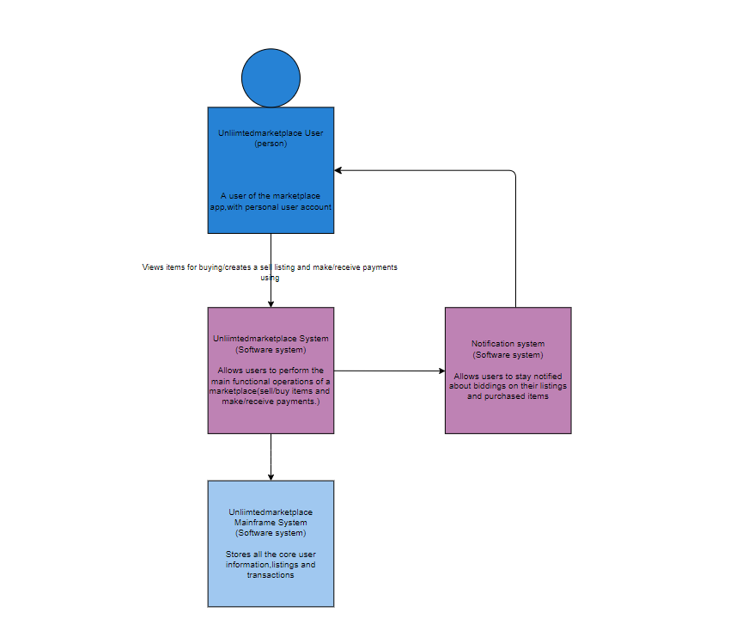

**C2 Diagram**

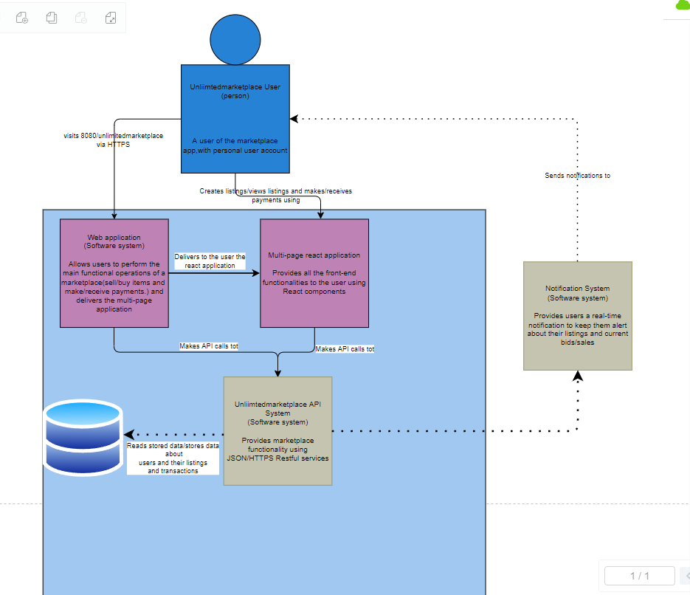

**C3 Diagram**

